Mariam Abdul Sattar

Profile of an Internet Technology: Cloud Services

MEDST 255: New Technologies

February 12, 2019

**CLOUD SERVICES**

The concept of cloud computed has existed since the 1960s. However, its use and existence has more commonly been heard since the year 2006. Cloud services is a new technology that “is a model for enabling convenient, on-demand network access to a shared pool of configurable computing resources (e.g., networks, servers, storage, applications and services) that can be rapidly provisioned and released with minimal management effort or service provider interaction." (National Institute of Standards and Technology). In simpler terms, a cloud service is the ability to access the Internet from any place and at any time. It allows a user to access their data, which is saved at a place besides their PC or hardware.

The way cloud computing works is by providing a hosted service over the Internet. There are two components: service end, where the information or data is saved and the user end: the individual or company network accessing the data.  Although the concept of cloud computing has evolved over time since its inception, it is generally classified in to three types: Software-as-a-service (SaaS), Platform-as-a-Service (PaaS) and Infrastructure-as-a-Service (IaaS).

Everyone – consumers, students, companies, and developers, uses cloud computing services. “If you use email, or go to a social network and post photos, access online document software, or use your company's hardware/software, you're probably using the cloud. You may also use it to store online tax or financial records. You can also use cloud computing to back up files for storage off your PC or Mac.” (Koba, 2011).

History:   
Amazon officially launched the first cloud computing service in 2006, which introduced and made the world aware about cloud services. However, the idea of cloud services was discussed long ago. IBM released one of the first major web-based hosting systems in 1972. This allowed employees to enter data remotely. The idea of an “intergalactic computer network” was introduced in the 1960s by JCR Licklider. The next big development in cloud services was in 1999 through the introduction of salesforce.com. In 2009, we saw the launch of Google Suite and Office 365 that led to cloud services being used by individuals on a next level. (Mohamed, Computer Weekly).

The development of cloud computing took a substantial amount of capital and was only used by larger organizations. AT&T and NASA were one of the first few companies that developed their first own private cloud service. There is still much research to be done in this field but the future of cloud services is bright. Each year, there is more development and cloud services being offered, particularly by Amazon, Google, Microsoft and more. There will be more hybrid cloud options available. Companies like Dropbox and Trello have made hybrid cloud solutions available to everyone.

Use:   
Three examples of cloud services on the Internet include:

1. **Microsoft Cloud:**

Microsoft has been one of the most revolutionary computing companies of all time. In recent years, they have helped make office IT systems run more efficiently by offering cloud-based solutions. With the introduction of Office 365, there has been a shift in saving work on the cloud rather than a local hard disk. Also, there is a rise in using Microsoft Office products online rather than using it locally. The new Microsoft cloud offers all of these on web-based applications so that updates and storage can all be hosted on the cloud.

**2. Google Drive:**

This is cloud computing in its most pure form. Google offers a public cloud for users to store documents, collaborate on documents, and host a number of unique applications. On the Drive, it offers a variety of apps and services that can be used by all such as sheets, docs, forms, slides, and much more.

**3. Apple iCloud:**

Apple’s signature cloud began primarily as a backup service for iPhone and MacBook users. It allows users to sync files, contacts, and other documents with the cloud that the data is kept secure even if something happens to the local device storage (Malik, 2015).

Future:  
The cloud services are here to stay and will experience exponential growth in the upcoming years. There is increased competition in this field that will lead to more innovate services and products being offered. The Vanson Bourne report identifies several benefits of using cloud services.

Efficiency is one of the most compelling reasons for companies to consider hosting programs and files in the cloud. While IT services are getting more expensive each year, cloud computing hopes to offer an affordable solution for storage, collaboration, and performance. Another major benefit of the cloud is it allows users to access their information from a mobile Internet connection. This is particularly useful among sales professionals who need to update their appointments and notes while out in the field. Further, companies can reduce their data server costs and the will require less space to store hardware equipment. Mobility and collaboration amongst users is also one of its greatest benefits. Despite the benefits of cloud services, there are concerns of security and risks with using this service. There are possible barriers to this service that includes loss of data or control (Coles, 2018).

“The future of cloud computing is a unique architecture based on the Computing Cell that consistently provides best-of-breed software infrastructure, including encryption, authentication, network segmentation, data integrity and data management across multiple public clouds.” (Tom Gillis, Founder & CEO of Bracket Computing).

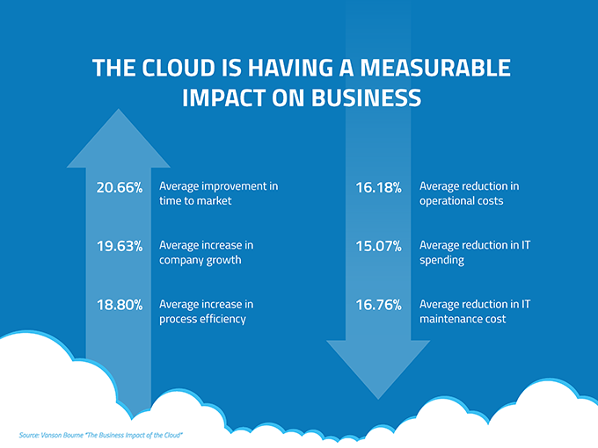

**WORKS CITED**

“A History of Cloud Computing.” *ComputerWeekly.com*, www.computerweekly.com/feature/A-history-of-cloud-computing.

“Cloud Computing 101 - Learn The Basics in 5 Minutes | CloudAbouts.” *Cloud Abouts*, 9 Sept. 2018, cloudabouts.com/what-is-cloud-computing/.

Coles, Cameron. “11 Advantages of Cloud Computing in 2018 | Skyhigh Networks.” *Skyhigh*, Skyhigh Networks, 16 Jan. 2019, [www.skyhighnetworks.com/cloud-security-blog/11-advantages-of-cloud-computing-and-how-your-business-can-benefit-from-them/](http://www.skyhighnetworks.com/cloud-security-blog/11-advantages-of-cloud-computing-and-how-your-business-can-benefit-from-them/).

Koba, Mark. “Cloud Computing 101: Learning the Basics.” *CNBC*, CNBC, 17 June 2011, [www.cnbc.com/id/43077233](http://www.cnbc.com/id/43077233).

Mell, Peter. “The NIST Definition of Cloud Computing.” *NISTIR 8179 Criticality Analysis Process Model | CSRC*, National Institute of Standards and Technology, 28 Sept. 2011, csrc.nist.gov/publications/detail/sp/800-145/final.